# **FROM 19st June TO 24th June**

# **Project ID:**

# **2021J_BV01_BCI Browser**

# **Project Title:**

# **Design and development of Brain Computer Interface Browser on Web and Mobile**

# **Summary:**

* Study of designing hybrid bci system
* A hybrid BCI must fulfill the following four criteria like any BCI:

a) The device must rely on signals recorded directly from the brain;

b) There must be at least one recordable brain signal that the user can intentionally modulate to effect goal-directed behavior;

c) Real time processing;

d) The user must obtain feedback

* The objective of this BCI research is to design a simple hybrid BCI platform that translate disabled people’s intentions into a control signal for an external device such as a computer.
* With this platform, a patient can select items from a (6×6) matrix on the screen in order to spell characters or phrases. To achieve this, we use two-modality (Steady state visual evoked potential & P300 Potential) sequentially for detecting desired character and we expect to improve the performance of the single-modality (only P300) BCI systems.
* We have only six frequencies in a 6×6 speller matrix that we should detect one-group characters with same frequencies through six groups.
* We must detect desired character that there is in selected group in previous section through 36 characters. We used two different types of software to design our hybrid BCI and we achieved a relatively high classification accuracy with our hybrid system.

# 

# 

# **Detail:**

**Design, Implementation and Evaluation of a Real-time P300-based Brain-Computer Interface System**

P300 is an event related potential (ERP) that occurs in brain signals when the subject is exposed to visual or auditory stimulation. The P300 speller paradigm we use was first introduced by Farwell and Donchin. They reported their results on 4 healthy subjects, with a rate of 2.3 letters per minute with 95% accuracy.

**METHODOLOGY**

**A. Hardware Setup-:**

The data are recorded and digitized with a 64-channel BioSemi ActiveTwo EEG amplifier in a Faraday Cage, void of electromagnetic interference. Active electrodes are utilized, attached to the electrode cap with conductive gel. The recorded data are digitized at 2048 Hz and sent to a laptop with a dual-core processor, which records the incoming data to a hard disk. The laptop is also used for stimulation and is responsible for sending trigger signals to the amplifier during the experiment.

**B. Software Setup-:**

For offline analysis, the data are recorded in BioSemi ActiView software, and for online analysis in MATLAB, via a modified version of a MEX interface developed by Hoffmann. The classification and other analyses are also done in MATLAB and the visual stimulus is developed in C#.

**C. Stimulus -:** Flexible stimulus system allows any matrix size, cell content customization (letters or shapes), different coloring and stimulation schemes as displayed . Also, each flash duration and ISI (inter-stimulus interval) can be specified. Overall, these options can be saved as presets to be used again later on. We present our results in the most well known stimulus type, a 6x6 matrix of characters, so that they can be compared to existing results based on this stimulus. This stimulus is a 6x6 matrix originally proposed by Farwell and Donchin that incorporates letters and numbers in each cell. The rows and columns of the matrix are highlighted in a block-randomized fashion; i.e. in 12 flashes, each row and column is flashed exactly once. Each flash lasts for 125 ms, and after each one is a period of 175 ms where none of the cells are highlighted. Therefore, each stimulus lasts 300 ms. Note that in order to define a letter, there should be at least two flashes, one row and one column, where the cell at the intersection holds the target letter. Offline analyses are done in the standard grey/white matrix. Online analyses are done in a random-colored matrix where each highlight is in a different color.

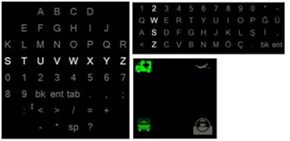

**D. Terminology-:** Offline analysis means the experimenter has prior knowledge on the letters for both training and test sets, and the analysis is done after raw data are recorded. Online analysis means the experimenter dictates only the letters for the training set and has no prior knowledge of letters in the test set and the system produces estimated letters and displays them to the subject in real time. Each flash of a row or column is called a trial. With block randomization in mind, 12 flashes that include all the rows and columns flashing constitute a trial group. According to timings reported in the previous section, a trial group lasts for 3.6 s. A determined number of trial groups make up a run. There are breaks between recordings of sessions in a session group, to let the subject rest and prepare for the next session. A trigger signal is an indication of the highlighted row/column and is sent over to the acquisition device. Trigger data are recorded alongside regular EEG data. An epoch is a determined period of recorded data that includes a trial.

**E. Data Acquisition-:** The electrodes used are Fp1, Fp2, P3, P4, PO7, PO8, Fz, Cz, Pz and Oz. Two reference electrodes are attached to each mastoid channel. Although Fp1 and Fp2 are generally ignored due to eye-blink artifacts, we have included them in our analysis to explore their effect on classification.

**F Preliminaries-:** For offline analyses in this study, there are two sessions in a session group, one being the training session and the other, the test session. Other than a few minor exceptions, the training session of each subject featured 8 runs that had “D E D E D E D E” as targets. The test sessions also featured 8 runs and included random letters, chosen either by the subject or the experimenter beforehand. Each epoch lasts for 1 second. The classifier is trained on the first session and tested on the second.

**G. Data pre-processing-:**  Proper pre-processing is an important factor in classification performance. We have conducted several different pre-processing schemes and observed that no scheme is best for all subjects. The definitive scheme used in all offline analyses is as follows: To get rid of irrelevant frequency components, the data are filtered with a 6th order Butterworth band-pass filter with a pass-band of 1 – 12 Hz. ActiView saves the data with respect to the common-mode sense (CMS) electrode. To obtain a greater SNR, the data are re-referenced to the average of two mastoid channels. For better performance of the classifier, the data should be normalized. But data with peaks lose resolution when normalized; therefore the data are first winsorized in a 10% frame, and zero-mean normalization follows next. Lastly, the data are decimated by 64. After decimation, each epoch is represented with 32 samples. The feature vector for each epoch is then the concatenation of filtered data from each electrode, i.e. a vector of 320 samples for 10 electrodes. We found out that in general, subjects blink rarely during each run and Fp1 and Fp2 contribute positively to the classification performance, especially when eye-blink artifacts are removed by winsorization. We have observed that half of the subjects performed better with normalization and winsorization, and the other 118 half performed better without them. In offline analysis, the results are generated according to the scheme the subject was best at. In online analysis, normalization and winsorization are applied to all subjects.

**H. Classification-:** For the classification algorithm, we used Bayesian Linear Discriminant Analysis (BLDA). A derivative of Fisher’s LDA, BLDA gives probabilistic output of test data, incorporates feature selection based on discriminative power and learns regularization parameters automatically from the training set. Averaging of multiple trials is frequently used to increase the SNR of P300 waves. Rather than using averaging, in our work, we incorporate information from multiple trials by probabilistic updates as new trial data are received. In particular, BLDA calculates a score for each epoch of test data, reflecting its similarity to the underlying classes. Scores are added up in consecutive trial groups until a firm separation between scores is present. For offline analysis, the sum of scores are checked at the end of each trial group and the row and column with the maximum scores are selected as answers of classification, and are compared with actual targets to generate the accuracy plots in Figure 2. Since actual targets are unknown to the experimenter in online analyses, the classifier has to decide by itself when to end each run. This is done by using margins in scores. A safe margin is determined and when the column and the row with the highest scores have that margin between themselves and the next best ones, the character at the intersection of these two is presented as the decisive answer of the classifier.

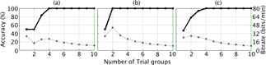

Figure 2 tells us that 48% of the time the classifier predicts the right answer in the first trial group. The classifier has correct answers in 2 trial groups 81% of the time and so on.

**DESIGNING HYBRID BCI SYSTEM**

According to brain activity patterns of EEG, BCIs are divided into different types. The most important of these patterns called ERP (Event Related Potentials) which appears after particular events in the EEG signal. Combining various types of BCI systems is called hybrid BCI and increases the efficiency of BCI system.

A hybrid BCI must fulfill the following four criteria like any BCI:

a) The device must rely on signals recorded directly from the brain;

b) There must be at least one recordable brain signal that the user can intentionally modulate to effect goal-directed behavior;

c) Real time processing;

d) The user must obtain feedback

**P300 MI BASED BCI**

P300 is a reliable BCI type for selecting one item out of several items and can be used for discrete control commands. On the other hand, due to the low degree of freedom presented by MI-based BCI, this type of BCI is more efficient for continuous control commands.

P300 and MI were introduced to be components of the hybrid BCI in robotic control decision applications. Parallel and asynchronous classifications were introduced. The system task was to detect the intended pattern.

Classification accuracy of hybrid model was evaluated during the experiment.

* Sixty trials were presented to four subjects: thirty trials for P300 presentation and thirty trials for MI. During the second thirty trials, the P300 stimuli were also presented but the subjects were not supposed to pay any attention to the stimuli. Empirical results indicated that subjects could achieve good control over the hybrid BCI.
* In particular, subjects could switch spontaneously and reliably between the two brain activity patterns. The hybrid classification reached an average P300 classification accuracy of 82% and the hybrid system reached an average MI classification accuracy of 71%.
* In conclusion, the performance of the hybrid system allows for the reliable control of devices such as robots.

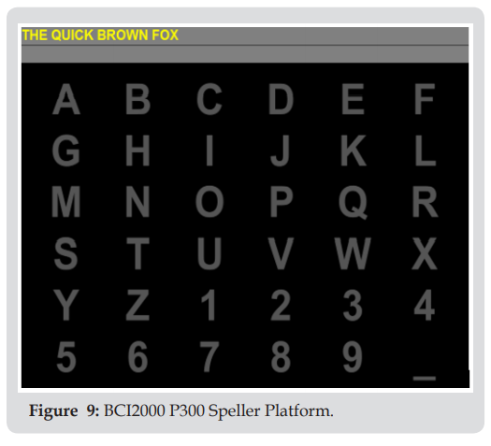

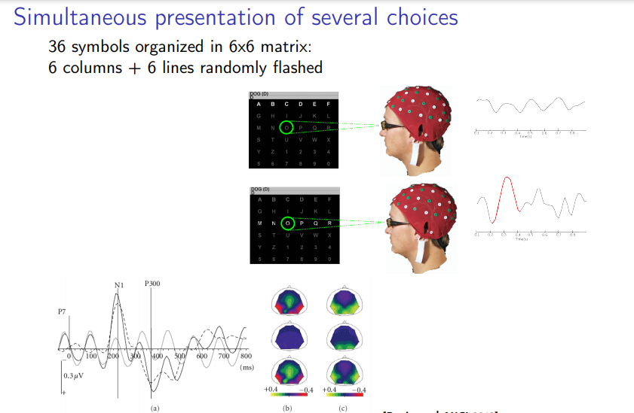

The objective consists of two parts:

* The first objective of this BCI research is to design a simple hybrid BCI platform that translate disabled people’s intentions into a control signal for an external device such as a computer. With this platform, a patient can select items from a (6×6) matrix on the screen in order to spell characters or phrases. To achieve this, we use two-modality (Steady state visual evoked potential & P300 Potential) sequentially for detecting desired character and we expect to improve the performance of the single-modality (only P300) BCI systems.
* The second objective of this BCI research is to use a low cost device for recording brain signals instead of expensive device that gives us good performance relatively.

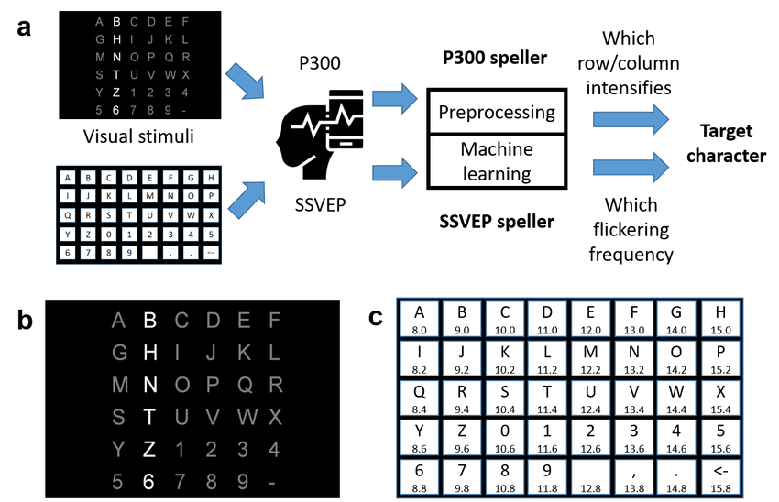

**FIGURE:** WORKING OF HYBRID BCI

**RESULT:**

Our hybrid BCI system consists of two sections including SSVEP condition and P300 condition. First, We have only six frequencies in a 6×6 speller matrix that we should detect one-group characters with same frequencies through six groups.

Second, we must detect desired character that there is in selected group in previous section through 36 characters.

We used two different types of software to design our hybrid BCI and we achieved a relatively high classification accuracy with our hybrid system.